Customer Shopping Behavior Analysis
1.Project Overview
This project focuses on analyzing 4,500 customer records to uncover meaningful insights into customer purchasing behavior, sales trends, product performance, customer segmentation, and subscription patterns. The analysis helps identify key business trends and supports data-driven decision-making.
2. Dataset Summary
Rows: 4,500
Columns: 20
Calculated Column: Customer Segment (created in Power BI)
Key Features:
Customer details (Age, Gender, Location, Subscription Status)
Purchase details (Item Purchased, Category, Purchase Amount INR, Season, Size, Color, Unit sold, Unit price)
Shopping behavior (Discount Applied, Previous Purchases, Frequency of Purchases, Payment Method, Review Rating, Shipping Type)
Tools Used: Python, PostgreSQL, SQL, Power BI
Missing Data: 54 values in Review Rating column
3. Exploratory Data Analysis using Python
We began with data preparation and cleaning in Python:
● Data Loading: Imported the dataset using pandas.
● Initial Exploration: Used df.info() to check structure and .describe() for summary statistics.
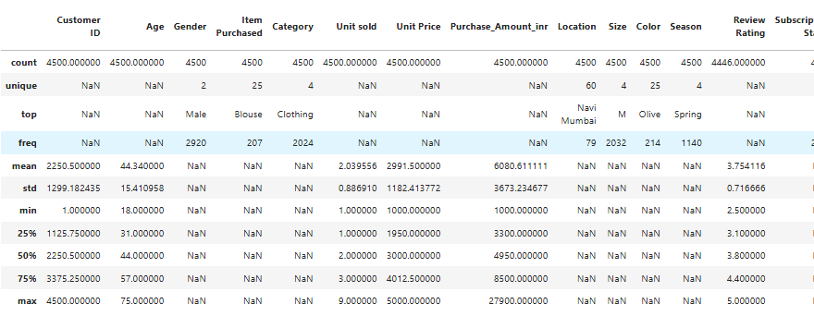
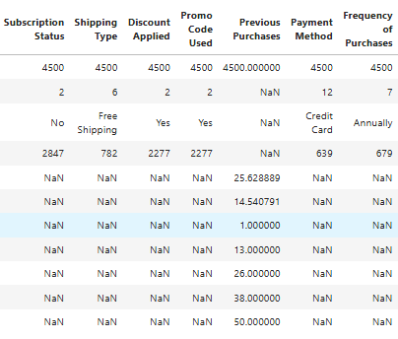

Missing Data Handling: Checked for null values and imputed missing values in the Review Rating column using the median rating of each product category.
● Column Standardization: Renamed columns to snake case for better readability and documentation.
● Feature Engineering:
○ Created age_group column by binning customer ages.
○ Created purchase_frequency_days column from purchase data.
● Data Consistency Check: Verified if discount_applied and promo_code_used were redundant; dropped promo_code_used.
● Database Integration: Connected Python script to PostgreSQL and loaded the cleaned DataFrame into the database for SQL analysis.
4. Data Analysis using SQL (Business Transactions)
We performed structured analysis in PostgreSQL to answer key business questions:
- Revenue by Category – Compared total revenue generated across different product categories.
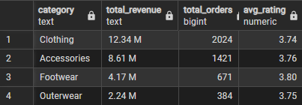

- Revenue by Location – Identified locations generating the highest total revenue.
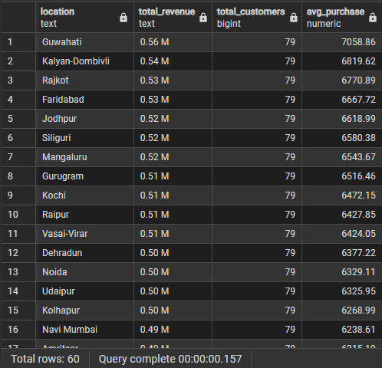

- Top 5 Products by Average Rating – Identified the five products with the highest average customer review ratings.
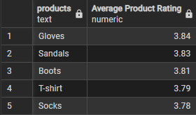

- Top 5 Payment Methods by Revenue – Identified the five payment methods contributing the most to total sales.

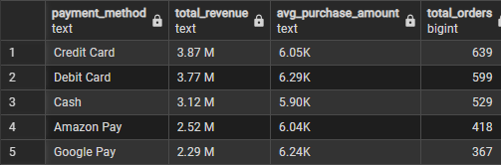

- Revenue By Season – Compared total revenue generated across different seasons to identify the highest-performing season.
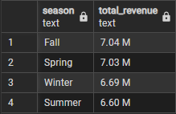

- Average Spend by Subscription Status – Compared average purchase amounts of subscribed and non-subscribed customers.
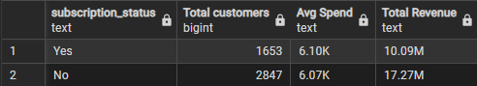

- Revenue by Gender – Compared total revenue generated by male vs. female customers.
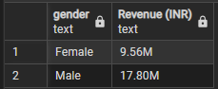

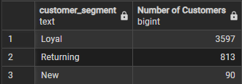
- Customer Segmentation – Analyzed the distribution of customers across New, Returning, and Loyal segments.

- Purchase Frequency Distribution – Analyzed the distribution of customers across different purchase frequency groups to understand recurring shopping patterns.
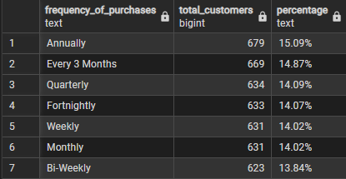

- Revenue by Age Group – Compared total revenue generated across different customer age groups.
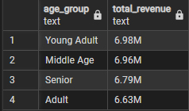

5. Dashboards in Power BI
Dashboard 1 : Customer Sales & Product Performance
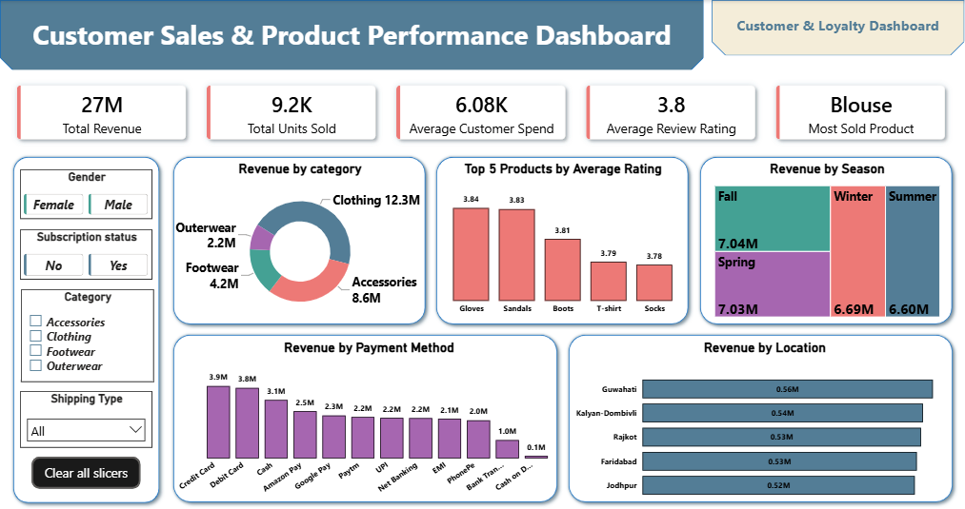

Dashboard 2 : Customer Behavior & Loyalty Analysis
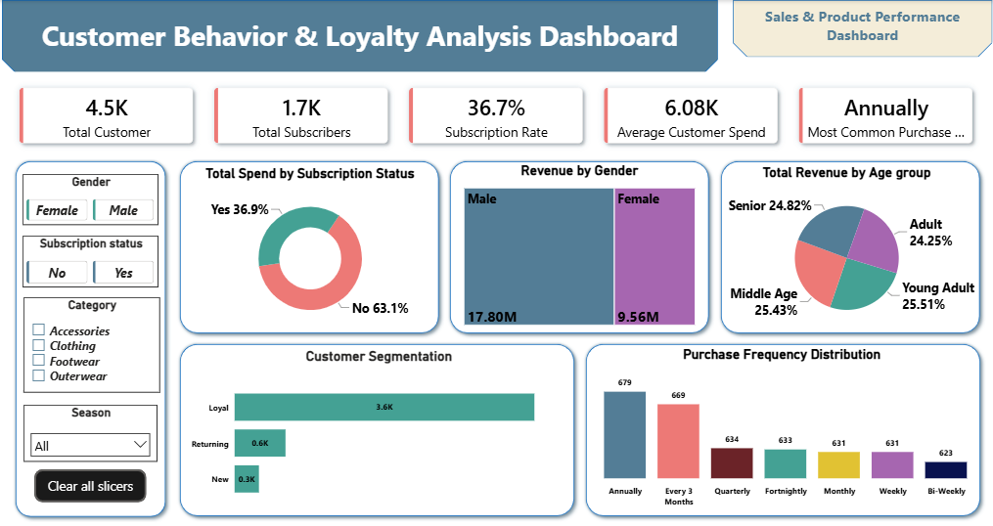

6. Business Recommendations
● Optimize Inventory – Stock high-demand products to prevent missed sales.
● Cross-Sell Products – Bundle popular products with lower-performing categories.
● Personalize Offers – Use customer behavior and demographics for targeted promotions.
● Improve Customer Experience – Leverage ratings and feedback to improve products and services.
● Expand Market Reach – Target underperforming locations with focused marketing campaigns.
● Optimize Payments – Prioritize popular payment options for a smoother checkout experience.

